Separate Biology - Summer Work Year 10
Summer 2020

Review of term 5 and 6

Context: Below are some optional activities that will help you to review and consolidate what you have learnt through home learning and importantly, give you the opportunity to apply your understanding to exam style questions.

The tasks below are levelled. Complete tasks that will help and challenge you.

Essential:

- Continue to use Tassomai 3-4 times a week to complete your daily goal. Currently it is set up to test all of your science (biology, chemistry and physics) knowledge for paper 1.

- Review and revise the topics below using BBC Bitesize. Importantly use the ‘test’ section/ tab when revising and complete the sample exam questions. This will secure your understanding and highlight areas to revise.

Bio D – Ecology 1
Adaptations and interdependence – https://www.bbc.co.uk/bitesize/guides/z9pd6yc/revision/1
Organisation of an Ecosystem - https://www.bbc.co.uk/bitesize/guides/z9nwtv4/revision/1

Bio F - Bioenergetics
Revision (all sections) – https://www.bbc.co.uk/bitesize/topics/zgws7p3
Sample exam questions –https://www.bbc.co.uk/bitesize/guides/zgwf4qt/revision/1

Challenge:

For both the tasks below, you do not need to print these, just write your answers on paper – if you cannot do a question because of this, move on.

- Complete the sample assessment paper for separate biology:
Paper - https://filestore.aqa.org.uk/resources/biology/AQA-84611H-SQP.PDF
Mark scheme – https://filestore.aqa.org.uk/resources/biology/AQA-84611H-SMS.PDF

- Complete the Grasp It questions. Questions page 2 onwards, answers from page 14 to self assess.

Extend:

- Complete the 5 questions, 5 words, 5 answers activity. Page 25 onwards.

Challenge – Grasp-it
A: Bioenergetics Part 1 - Photosynthetic reaction, rate of photosynthesis and use of glucose from photosynthesis.
- Phytoplankton are microscopic aquatic plants. They utilise the energy transferred from the sun for photosynthesis.

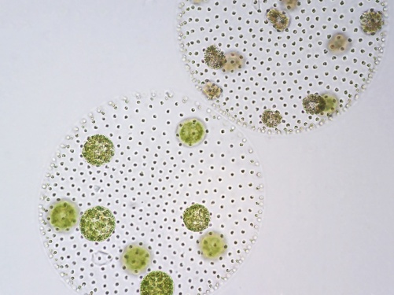
Scientists working in the North Sea collected 500 samples of sea water at the same depth and location every month for a whole year. They measured the number of phytoplankton and water temperature for each sample and calculated the mean. The graph shows the mean number of phytoplankton and water temperature per month.
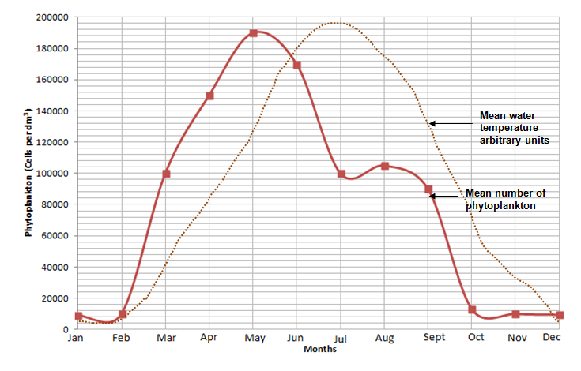
100 000
190 000
- Explain why the numbers of phytoplankton are lower in winter months. (2)
........................................................................................................................................................................................................................................................................................................................................................................................................................................................................................................................................................................................................................................

- Calculate the percentage decrease in numbers of phytoplankton between May and July. Write your answer to 3 significant figures. (3)

.............................

- Suggest the cause and reason why the numbers of phytoplankton fall at the start of summer. (2)
........................................................................................................................................................................................................................................................................................................................................................................................................................................................................................................................................................................................................................................................................................................

- Van Helmont was a scientist born in the Netherlands in 1580. It was generally believed at that time that plants gained mass by eating soil.
Van Helmont designed an experiment to test this idea. The results of his experiment are seen below.
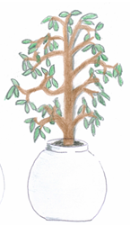
Only water was added for five years.
Willow plant in same iron pot.
Willow plant has a mass of 77.3kg
Mass of dry soil is 90.043kg
Willow plant in an iron pot.
Willow plant has a mass of 2.5kg
Mass of dry soil is 91kg

- Write a conclusion for this experiment using only the information provided. Explain your reasoning. (4)
........................................................................................................................................................................................................................................................................................................................................................................................................................................................................................................................................................................................................................................
- List two extra investigations that would be needed to prove that the plant gained mass due to photosynthesis occurring. (2)
........................................................................................................................................................................................................................................................................................................................................................................................................................................................................................................................................................................................................................................

- There is a total of 7000 x 10⁹ tonnes of carbon dioxide in the atmosphere and photosynthesis converts 100 x 10⁹ tonnes per year into carbon compounds such as carbohydrates, protein or lipids. We call this carbon fixing.
- Calculate as a percentage how much carbon is fixed per year from the atmosphere. Express your answer to 2 significant figures. (2)

.........................................
- Suggest two reasons why the amount of carbon dioxide in the atmosphere stays relatively constant. (2)

.....................................................................................................................................................................................................................................................................................................................................................................................................................................................................................................................................................................................................................................

- A student carried out the practical which involved testing the effect of light intensity on the rate of photosynthesis. The pond weed was left to settle for 15 minutes in between each set of results being collected. The equipment was set up as shown below:
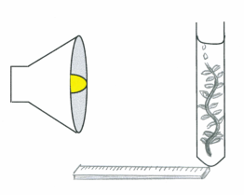
pondweed
0.2% sodium hydrogen
carbonate solution

bubbles of gas
bench Lamp
metre ruler
The student recorded the results in the table below:
Distance of lamp from boiling tube (cm) | Number of bubbles counted in 1 minute
 | Trial 1 | Trial 2 | Trial 3 | Mean number of whole bubbles | Light Intensity ( in standard form)  1/d²
20 | 10 | 15 | 18
40 | 10 | 12 | 16
60 | 9 | 10 | 14
80 | 6 | 7 | 10
100 | 3 | 4 | 6

- Determine the mean number of bubbles of gas collected for each distance and record in the table. (2)

- Calculate the light intensity for each experiment and record in the table (5)

- Plot a graph to show the effect of light intensity on the rate of photosynthesis. (4)

- Use your graph to estimate the number of whole bubbles which would be released from the pondweed when the lamp was at a distance of 30cm. (3)

.......................................................

- All the data shows an increase in number of bubbles collected during trial 3. Suggest two reasons why this may have occurred. Explain how this could be verified and how would you improve the method for the future. (6)

..................................................................................................................................................................................................................................................................................................................................................................................................................................................................................................................................................................................................................................................................................................................................................................................................................................................................................................................................................................................................................................................................................................................................................................................................................................................................................................................................................................................................................................................................................................................................................................................................................................................................................................................

- Photosynthesis is an endothermic reaction. Explain what this statement means. (2)

............................................................................................................................................................................................................................................................................................................

Extended Response question

- A farmer in the UK decided to grow lemon trees in two greenhouses in order to sell the fruit locally.
He had grown some lemon trees outside but these had not produced sufficient lemons to make it worthwhile. He decided to heat one of the greenhouses to 35°C and the other to 45°C.
There were the same numbers of lemon trees in each greenhouse and all other factors were kept constant. Both greenhouses contained healthy plants.
The lemons were all sold at 55p each.

 | Greenhouse A (35°C) | Greenhouse B (45°C)
Number of lemons produced in one year | 1050 | 879
Cost to heat the greenhouse per year | £438.00 | £492.80
Profit made

- Using the data given calculate the profit that the farmer made from each greenhouse and complete the table. (4)

- The farmer was surprised by the results.

Use your knowledge of limiting factors to explain the results and suggest three changes the farmer should make to increase productivity and profit for the following year in Greenhouse A. (6)

..............................................................................................................................................................................................................................................................................................................................................................................................................................................................................................................................................................................................................................................................................................................................................................................................................................................................................................................................................................................................................................................................................................................................................................................................................................................................................................................................................................................................................................................................................................................................................................................................................................................................................................................................................................

- The following graph shows the effect of light intensity on the rate of photosynthesis for two plant species.

- Explain which plant is most likely to thrive in sunny positions in a garden. (3)
..................................................................................................................................................................................................................................................................................................................................................................................................................................................................................................................................................................................................................................................................................................................................................................................................
- Suggest why species A is unable to further increase the rate of photosynthesis even though it is in the same environmental conditions as species B and both receive the same amount of water. (2)
..................................................................................................................................................................................................................................................................................................................................................................................................................................................................................................................................................................................................................................................................................................................................................................................................

- The graph shows the effect of temperature and carbon dioxide concentration on the rate of photosynthesis.

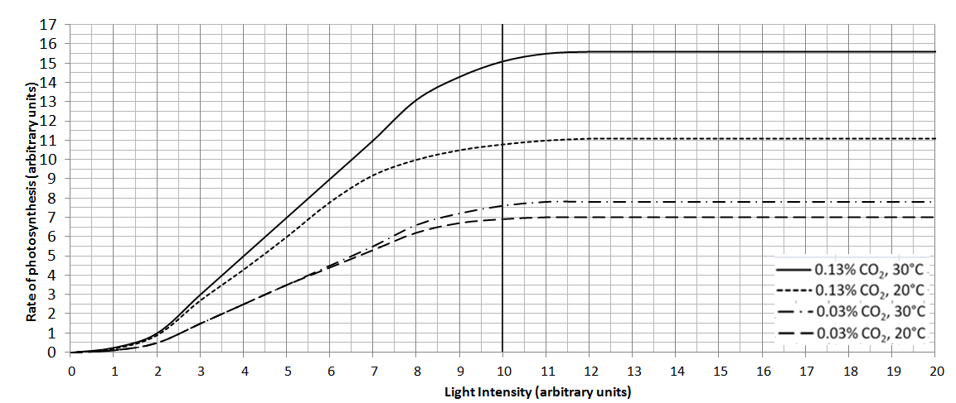

If light intensity is kept constant at 10 units, calculate the percentage increase in photosynthetic rate when:

- temperature is increased from 20°C to 30°C and carbon dioxide is kept constant at 0.03%. (2)

..............................................

- carbon dioxide is increased from 0.03% to 0.13% and temperature is kept constant at 20°C. (2)

..............................................

B. Bioenergetics part 2 – Respiration, response to exercise and metabolism
1. Describe the differences between anaerobic and aerobic respiration in animal cells. (4)
..............................................................................................................................................
..............................................................................................................................................
.............................................................................................................................................
..............................................................................................................................................
..............................................................................................................................................
.............................................................................................................................................
2. ‘Some uses for the energy transferred from respiration are the same in plants and animals and some are different.’ Explain what this statement means. (3)
..............................................................................................................................................
..............................................................................................................................................
..............................................................................................................................................
..............................................................................................................................................
..............................................................................................................................................

3. Explain why the mitochondria in cells are important. (3)
.............................................................................................................................................
..............................................................................................................................................
..............................................................................................................................................
..............................................................................................................................................
..............................................................................................................................................
4. Suggest how the rate of respiration in an animal cell might change over a typical 24 hour period. (2)
.............................................................................................................................................
..............................................................................................................................................
..............................................................................................................................................
..............................................................................................................................................

5. A scientist was investigating the rate of active uptake of potassium ions by wheat root hair cells in aerobic and anaerobic conditions. The results are shown in the graph.
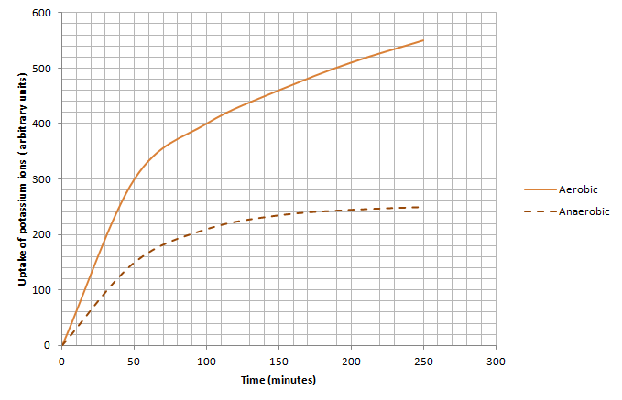

- Explain why the roots of a plant must have a good supply of oxygen in order to take in mineral salts. (3)
..........................................................................................................................................................
..........................................................................................................................................................
......................................................................................................................................................... ..........................................................................................................................................................
.........................................................................................................................................................

- The rate of potassium ion transfer from the soil to the root hair cell between 150 and 200 minutes in the anaerobic experiment was 0.2 arbitrary units per minute.

Determine the rate of transfer of potassium ions between 150 and 200 minutes for aerobic respiration. Show your working. (3)
..........................................................................................................................................................
..........................................................................................................................................................
......................................................................................................................................................... ..........................................................................................................................................................
.........................................................................................................................................................
6. A patient was linked to a heart rate monitor whilst doing exercise.
Explain why the patient’s heart rate increased from 75 beats per minute to 120 beats per minute. (5)

..............................................................................................................................................
..............................................................................................................................................
.............................................................................................................................................
..............................................................................................................................................
..............................................................................................................................................
.............................................................................................................................................
..............................................................................................................................................
..............................................................................................................................................
.............................................................................................................................................

- Extended response question:
Wild dogs tend to rely on stamina and wear down their prey with a long chase which can be up to an hour. Their muscles fatigue slowly as they pace themselves.
This graph shows how much energy is being produced for muscle cells from anaerobic and aerobic respiration during exercise.

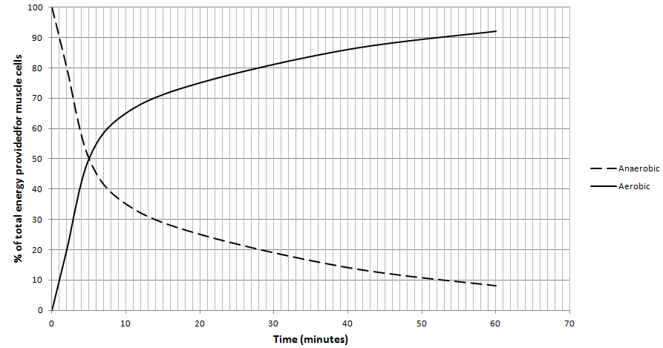

Using the information provided and your own knowledge describe and explain how energy is being transferred to the muscles in the dog at the start, middle and end of a 60 minute hunt. Include word equations in your answer. (6)

..............................................................................................................................................
..............................................................................................................................................
..............................................................................................................................................
..............................................................................................................................................
..............................................................................................................................................
..............................................................................................................................................
..............................................................................................................................................
..............................................................................................................................................
..............................................................................................................................................
..............................................................................................................................................

Grasp It Answers
A: Bioenergetics Part 1 - Photosynthetic reaction, rate of photosynthesis and use of glucose from photosynthesis.
- Phytoplankton are microscopic aquatic plants. They utilise the energy transferred from the sun for photosynthesis.

Scientists working in the North Sea collected 500 samples of sea water at the same depth and location every month for a whole year. They measured the number of phytoplankton and water temperature for each sample and calculated the mean. The graph shows the mean number of phytoplankton and water temperature each month.
100 000
190 000
- Explain why the numbers of phytoplankton are lower in winter months. (2)
Lower temperature of water so metabolism is slow, so growth and reproduction will be slow.
Lower rate of photosynthesis as light intensity is lower. The phytoplankton cannot synthesise as much glucose and so many will die.
- Calculate the percentage decrease in numbers of phytoplankton between May and July. Write your answer to 3 significant figures. (3)
3 marks for correct answer to 3 significant figures
2 marks for correct answer but not to 3 sf
1 mark for incorrect answer but mentions 90 000

190 000 -100 000 = 90 000
90 000 / 190 000 = 0.47
0.47 x100 = 47.4% decrease

- Suggest the cause and reason why the numbers of phytoplankton fall at the start of summer. (2)
1 for a cause and 1 for related reason:
Water temperature is high enough
to denature metabolic enzymes causing death of phytoplankton.
More phytoplankton being eaten by animals
as they breed and increase in number.
- Van Helmont was a scientist born in the Netherlands in 1580. It was generally believed at that time that plants gained mass by eating soil.
Van Helmont designed an experiment to test this idea. The results of his experiment are seen below.
Only water was added for five years.
Willow plant in same iron pot.
Willow plant has a mass of 77.3kg
Mass of dry soil is 90.043kg
Willow plant in an iron pot.
Willow plant has a mass of 2.5kg
Mass of dry soil is 91kg

- Write a conclusion for this experiment using only the information provided. Explain your reasoning. (4)
Conclusion: Increase in mass of willow plant is linked to the addition of water. (1)
Three explanations why: (3)
The mass of the plant increases over five years by 74.8 Kg.
The soil mass has not changed significantly over 5 years.
The only extra factor added to the plant was water, therefore this must have contributed to the increase in plant mass.
The pot is the same and so did not influence results

- List two extra investigations that would be needed to prove that the plant gained mass due to photosynthesis occurring? (2)
Two from:
Remove light but keep all other factors constant.
Remove carbon dioxide and keep all other factors constant.
Remove leaves/chlorophyll and keep all other factors constant.

- There is a total of 7000 x 10⁹ tonnes of carbon dioxide in the atmosphere.Photosynthesis converts 100 x 10⁹ tonnes per year into carbon compounds such as carbohydrates, protein or lipids. We call this carbon fixing.
- Calculate as a percentage, how much carbon is fixed per year from the atmosphere. Express your answer to 2 significant figures. (2)
100/7000 = 0.014
0.014 x100 = 1.4
1.4%
2 marks for correct answer of 1.4%
1 mark for 1.43% or 1.428%
- Suggest two reasons why the amount of carbon dioxide in the atmosphere stays relatively constant. (2)
Two from:
Combustion
Respiration
Decay

- A student carried out the practical which involved testing the effect of light intensity on the rate of photosynthesis. The pondweed was left to settle for 15 minutes in between each set of results being collected. The equipment was set up as shown below:
pondweed
0.2% sodium hydrogen
carbonate solution

bubbles of gas
bench Lamp
metre ruler

The student recorded the results in the table below:
Distance of lamp from boiling tube (cm) | Number of bubbles counted in 1 minute
 | Trial 1 | Trial 2 | Trial 3 | Mean number of whole bubbles | Light Intensity ( in standard form)  1/d²
20 | 10 | 15 | 18 | 10 + 15 + 18 = 43  43/3 =14.33  14 bubbles | 20 x 20 = 400  1/400= 0.0025  In standard form = 2.5 x 10⁻³
40 | 10 | 12 | 16 | 13 | 6.3 x 10⁻⁴
60 | 9 | 10 | 14 | 11 | 2.8 x 10⁻⁴
80 | 6 | 7 | 10 | 8 | 1.6 x 10⁻⁴
100 | 3 | 4 | 6 | 4 | 1.0 x 10⁻⁴

- Determine the mean number of bubbles of gas collected for each distance and record in the table. (2)
See table: 2 marks all correct
1 mark for 4 correct and 1 error
0 marks for more than 1 error

- Calculate the light intensity for each experiment and record in the table. (5)
See table: 1 mark for each correct calculation expressed in standard form
Maximum 2 marks if not in standard form.
Standard form is expressed in numbers between 1 and 10

- Plot a graph to show the effect of light intensity on the rate of photosynthesis. (4)

Line graph (1)
Plots pointed accurately (1)
Line of best fit drawn (curve) (1)
Axes labelled correctly (1)
Note: Must have drawn Light intensity rather than Distance.

- Use your graph to estimate the number of whole bubbles which would be released from the pondweed when the lamp was at a distance of 30cm. (3)

Look at graph and read off the number of bubbles at 1/d² figure of 1.1 x10⁻³ or 0.0011 (1 mark for using correct light intensity)
Approximately 13 or 14 (Use student graph for the answer here) (1 mark for reading own graph correctly)

Rounded up as can’t have half a bubble and it is an estimation. (1 mark for whole number answer)

- All the data shows an increase in number of bubbles collected during trial 3. Suggest two reasons why this may have occurred. Explain how this could be verified and how would you improve the method for the future. (6)

Level 3 (5-6 marks)
Potential issues with the experimental design are coherently described and explained. A logical method of verification is given for both issues and appropriate redesigns of the method suggested as a result.
Level 2 (3-4 marks)
Descriptions of potential issues are given with some explanation. Some verification procedures identified but these may not always be consistent with the issue. Improvements suggested.
Level 1 (1-2 marks)
Simple statements are made which demonstrate some understanding of the issues. The response lacks a logical structure.

Biological content

Water was warming up from the lamp by the time trial 3 occurred
and this increased the rate of photosynthesis.
Verify this by repeating the experiment and take temperature readings every 30 seconds.
If temperature was changing then use a heat shield or an LED lamp to reduce this
and check that the water temperature was the same at the start and end of each trial.

The pondweed had not yet reached the maximum rate of photosynthesis when recording began in trial 1
but it had settled by the time trial 3 occurred.
Verify by repeating experiment and doing all distances once and then repeating to see if similar results occur.
Leave the pondweed to settle for 30 minutes before taking each reading.
Check that the trial results are all similar and if not leave the experiment longer to settle.

- Photosynthesis is an endothermic reaction. Explain what this statement means. (2)

Photosynthesis is an endothermic reaction because it needs an input of energy.
The energy input comes from the sun.

Extended Response question

- A farmer in the UK decided to grow lemon trees in two greenhouses in order to sell the fruit locally.
He had grown some lemon trees outside but these had not produced sufficient lemons to make it worthwhile. He decided to heat one of the greenhouses to 35°C and the other to 45°C.
There were the same numbers of lemon trees in each greenhouse and all other factors were kept constant. Both greenhouses contained healthy plants.
The lemons were all sold at 55p each.

 | Greenhouse A (35°C) | Greenhouse B (45°C)
Number of lemons produced in one year | 1050 | 879
Cost to heat the greenhouse per year | £438.00 | £492.80
Profit made | 1050 x 0.55p = 577.50 (1)  577.50 – 438 = £139.50 (1) | 879 x 0.55p = £483.45 (1)  483.45 – 492.80 = - £9.35 (1)

- Using the data given calculate the profit that the farmer made from each greenhouse and complete the table. (4)
See table

- The farmer was surprised by the results.

Use your knowledge of limiting factors to explain the results and suggest three changes the farmer should make to increase productivity and profit for the following year in Greenhouse A. (6)
Level 3 (5-6 Marks)
A detailed and coherent explanation is provided that considers a range of relevant points with linked reasoning and provide appropriate suggestions for Greenhouse A which will increase both profit and productivity.
Level 2 (3-4 marks)
An attempt to describe relevant points with some linked reasoning. Appropriate suggestions are provided for Greenhouse A which may be linked to profit and productivity.
Level 1 (1-2 marks)
Discrete relevant points made which are often not linked to reasons. Suggestions made for improving greenhouse A with no appropriate link as to why or to profit and productivity.

Biology content
- At 35°C, the enzymes catalysing the photosynthetic reaction in the leaves are working under optimum conditions
- and so photosynthesis occurs at a maximum rate
- producing more glucose some of which is converted into carbohydrates stored in the lemons.

- At 45°C, the enzyme active sites are saturated
- and so no increase in photosynthesis occurs leading to no extra lemons being produced.
- The temperature is high enough for enzymes to start to become denatured and so ineffective.
- The extra heat being added to the greenhouse is wasted.

- Changes the farmer could make are:
- Use energy efficient glass to reduce heat loss to the environment saving money.
- Increase the amount of carbon dioxide so this is not acting as a limiting factor to the rate of photosynthesis and so increasing productivity and profit.
- Add lighting overnight to increase the hours that photosynthesis can occur and reducing light being a limiting factor during cloudy days and at night. This increases productivity and therefore profit.

- The following graph shows the effect of light intensity on the rate of photosynthesis for two plant species.

- Explain which plant is most likely to thrive in sunny positions in a garden. (3)
Species B (1)
Two from:
- Because as light intensity increases the rate of photosynthesis of species B continues to increase suggesting it normally experiences these types of intensities.
- Rate of photosynthesis in B is not limited until a much higher light intensity.
- A has a higher rate of photosynthesis at lower light intensities but the rate is limited by another factor earlier than B.

- Explain why species A might be unable to further increase the rate of photosynthesis even though it is in the same environmental conditions as species B and both receive the same amount of water. (2)
Two of:
Because it does not have enough chlorophyll/leaves and this acts as a limiting factor.
The chlorophyll in A is not adapted to working in high light intensities.
It does not have enough enzymes to catalyse the photosynthetic reaction to go faster.
Cannot mention carbon dioxide or water or light as question states these are not issues.

- The graph shows the effect of temperature and carbon dioxide concentration on the rate of photosynthesis.

If light intensity is kept constant at 10 units, calculate the percentage increase in photosynthetic rate when:

- temperature is increased from 20°C to 30°C and carbon dioxide is kept constant at 0.03%. (2)
  - – 6.9 = increase of 0.7 units (allow tolerance of +/- 1 unit for each measurement) (1)
0.7/6.9 x100 = 10.1% (1)

2 marks for correct answer with no working
Check the % using the student’s figures – do not penalise twice.

- carbon dioxide is increased from 0.03% to 0.13% and temperature is kept constant at 20°C. (2)
10.8 – 6.9 = increase of 3.9 units (tolerance of +/- 1 unit per measurement) (1)
3.9/6.9 x 100 56.5% increase (1)

2 marks for correct answer with no working
Check the % using the student’s figures – do not penalise twice.

B. Bioenergetics part 2 – Respiration, response to exercise and metabolism
1. Describe the differences between anaerobic and aerobic respiration in animal cells. (4)
Four from:
- Oxygen is required in aerobic respiration but not in anaerobic respiration.
- Carbon dioxide and water are the products of aerobic respiration. Lactic acid is the product for anaerobic respiration.
- Glucose is completely oxidised in aerobic respiration and only partially oxidised in anaerobic respiration.
- The efficiency of energy transfer is high in aerobic and low in anaerobic respiration.
- Aerobic respiration takes place in the mitochondria and anaerobic respiration occurs in the cytoplasm.

2. ‘Some uses for the energy transferred from respiration are the same in plants and animals and some are different.’ Explain what this statement means. (3)
- Plants and animals both use the energy to build larger molecules from smaller ones e.g. proteins from amino acids
- Animals also use the energy to enable muscles to contract and bring about movement
- Some animals use the energy to maintain a steady body temperature in a cold environment.

3. Explain why the mitochondria in cells are important. (3)
- Cells require energy for metabolic functions
- Mitochondria are the site of aerobic respiration
- Energy is released from aerobic respiration

4. Suggest how the rate of respiration in an animal cell might change over a typical 24 hour period. (2)
The rate will be higher during the day and when the body is active. At night, the body requires less
energy as it is less active and so the rate is reduced (but never stops).

5. A scientist was investigating the rate of active uptake of potassium ions by wheat root hair cells in aerobic and anaerobic conditions. The results are shown in the graph.
- Explain why the roots of a plant must have a good supply of oxygen in order to take in mineral salts. (3)
- Oxygen is needed for aerobic respiration
- which provides the energy which is needed for active uptake/transport
- Active uptake/transport is how minerals are taken into a plant from the soil against the concentration gradient.
- The rate of potassium ion transfer from the soil to the root hair cell between 150 and 200 minutes in the anaerobic experiment was 0.2 arbitrary units per minute.

Determine the rate of transfer of potassium ions between 150 and 200 minutes for aerobic respiration. Show your working. (3)
- 460 arbitrary units taken up at 150 minutes (1)
- 510 arbitrary units taken up at 200 minutes (1)
- Difference is 50 units over 50 minutes
- 50/50 = 1 arbitrary unit per minute is the rate of transfer. (1)
3 marks for correct answer with no working

6. A patient was linked to a heart rate monitor whilst doing exercise.
Explain why the patient’s heart rate increased from 75 beats per minute to 120 beats per minute. (5)
Any 5 points from:
- To increase blood flow
- To supply more food/sugar/glucose for respiration
- To supply more oxygen for aerobic respiration
- To supply energy to muscles at a faster rate
- To enable muscles to contract faster/work harder
- To remove lactic acid
- To remove carbon dioxide
- To remove heat

7. Extended response question:
Wild dogs tend to rely on stamina and wear down their prey with a long chase which can be up to an hour. Their muscles fatigue slowly as they pace themselves.
This graph shows how much energy is being produced for muscle cells from anaerobic and aerobic respiration during exercise.

Using the information provided and your own knowledge describe and explain how energy is being transferred to the muscles in the dog at the start, middle and end of a 60 minute hunt. Include word equations in your answer. (6)

Level 3 (5-6 marks)
A detailed and coherent answer which considers a range of points, correct word equations for aerobic and anaerobic respiration stated and/or an understanding shown in the answer, quotes relevant data from the graph and comes to logical conclusions.

Level 2 (3-4 marks)
An attempt to describe relevant points which come to a conclusion. The correct word equations are included. The use of data may be inconsistent at times.

Level 1 (1-2 marks)
Discrete relevant points made. The logic may be unclear and the conclusion if present may not be consistent with the reasoning. Use of data is inconsistent and at times inaccurate.

Biology content

Quotes correct word equations for anaerobic and aerobic respiration

Dog:
Start of hunt dog gets most of its energy from anaerobic respiration.
By the middle of the hunt – 25 minutes the dog’s muscles are mostly using energy released from aerobic respiration – 77% with some energy still coming from anaerobic respiration (27%)
By the end of the hunt at 50 minutes only 10% of the energy used is coming from anaerobic respiration.
The dog can run for long periods of time as the energy it uses is coming mainly from aerobic respiration. This produces more energy per glucose molecule than anaerobic respiration and the accumulation of lactic acid is minimised.

Extend: 5 questions, 5 words, 5 answers activity.

For each statement, use either the suggested website or your own text book to write a 5-point summary. In examinations, answers frequently require more than 1 key word for the mark, so aim to include a few key words.

It is important to stick to 5 sentences. It is the process of selecting the most relevant information and summarizing it, that will help you remember it.

Write concisely and do not elaborate unnecessarily, it is harder to remember and revise facts from a big long paragraph.

Finally, identify 5 key words that you may have difficulty remembering and include a brief definition. You might like to include a clip art style picture to help you remember it.

Example:

QUESTION: How does photosynthesis take place in plants?

Sources:

Website- http://www.s-cool.co.uk/gcse/biology/photosynthesis/revise-it/photosynthesis

Interactive - www.saps.org.uk/secondary/themes/1281

5 key sentences:

- Photosynthesis uses carbon dioxide and water to generate glucose and oxygen.
- Carbon dioxide and oxygen move in and out of the leaf, through stomata, via diffusion.
- Photosynthesis takes place in the palisade mesophyll where the cells have a high concentration of chloroplasts.
- Water enters the plants through the roots via osmosis and is transported to the leaves through the xylem.
- Light from the visible spectrum is used to provide the energy for this reaction to take place.

5 keywords:

- Photosynthesis
- Light energy
- Glucose
- Carbon dioxide
- Chlorophyll

QUESTION 1:

How does light intensity effect photosynthesis?
Sources:
Website – www.nuffieldfoundation.org/practical-biology/investigating-factors-affecting-rate-photosynthesis
Interactive - www.reading.ac.uk/virtualexperiments/ves/preloader-photosynthesis-full.html

QUESTION 2:

What do plants, and some algae, do with glucose made during photosynthesis?
Sources:
Website – www.bbc.co.uk/schools/gcsebitesize/science/add_aqa/photosynthesis/photosynthesisrev4.shtml
Interactive - www.indiana.edu/~oso/animations/potato.swf

QUESTION 3:

What can limit the rate of photosynthesis?
Sources:
Website – http://ib.bioninja.com.au/standard-level/topic-2-molecular-biology/29-photosynthesis/limiting-factors.html
Video - www.youtube.com/watch?v=xEhvsXG8cNs

QUESTION 4:

How do plants help reduce climate change?
Sources:
Website – www.bbc.co.uk/news/science-environment-14121360
Interactive - https://svs.gsfc.nasa.gov/10494

QUESTION 5:

Can biofuels reduce our impact on the environment?
Sources:
Website – www.theguardian.com/environment/2017/jul/14/biofuels-need-to-be-improved-for-battle-against-climate-change
Interactive - www.nationalgeographic.org/video/edu-bio-fuels/

